URGENT MEDICAL DEVICE FIELD ACTION NOTICE

Name of Affected Products: Embosphere® Microspheres
Action Required: Return Product to Merit Medical

Merit Medical Systems, Inc. (Merit) is voluntarily recalling specific lots of Merit Embosphere® Microspheres due to a supplier-related defect that may affect the device packaging sterile barrier. Specifically, certain lots may contain a hole in the blister packaging. This issue affects the lots and part numbers identified in the table below pertaining to the Merit Embosphere Microspheres Merit has chosen to remove the units from the market and request that you immediately stop using or distributing the affected lots and return the affected product to Merit as soon as possible.
Risk to Health:
According to Merit’s evaluation of health hazard(s), use of the affected product may result in exposure to pathogens/pyrogens, which could lead to infection. To date, Merit has not received any complaints or reports of patient harm or injury associated with this issue.

Affected Lot Table:

DESCRIPTION | UDI | CATALOG CODE | LOT NUMBER
Embosphere®.500-700 µm.2 mL.Syringe.Sterile.Steam. | 00884450116715 | S420GH/EUA | X3467294-1
Embosphere®.500-700 µm.2 mL.Syringe.Sterile.Steam. | 00884450109519 | S620GH/EUA | X3472987-1
Embosphere®.700-900 µm.2 mL.Syringe.Sterile.Steam. | 00884450364154 | S820GH/CAB | X3472923-A
Embosphere®.900-1200 µm.2 mL.Syringe.Sterile.Steam. | 00884450403136 | S1020GH/C | X3482321-5
Embosphere®.900-1200 µm.2 mL.Syringe.Sterile.Steam. | 00884450109519 | S1020GH/EUA | X3482321-1

Actions required of you:
- Immediately determine if any of the devices identified in the attached Customer Response Form (CRF) are within your facility.
  - A picture of the Embosphere® Microspheres is attached to help you identify the product (see image A).
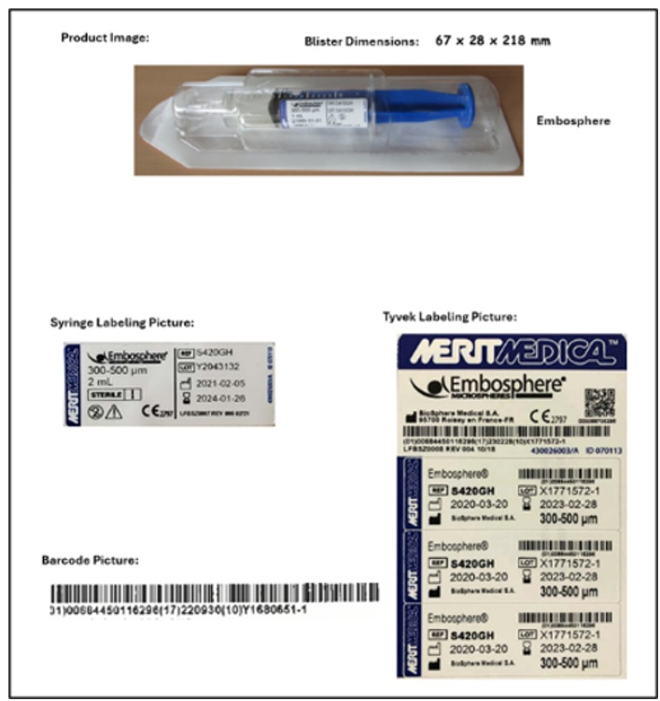
Image A. Embosphere® Microspheres Product / Label Images

- Immediately discontinue the use of the affected lots of the Embosphere® Microspheres.
- Ensure that applicable personnel within your organization are made aware of this recall.
- If the product has been further distributed to other facilities, institutions, or manufacturers, please ensure this notice is immediately shared with them and note the quantity distributed on the CRF. Additional distribution details may be required by health authorities.
- Please fill out, scan and email the completed Customer Response Form to Customer Service at CustomerServiceCanada@merit.com within 7 business days. All affected products shipped to you must be accounted for on the CRF.
- Immediately return all affected lots in your possession to Merit, per the instructions in the attached CRF.
- When requesting replacement for Embosphere® Microspheres please utilize the table below for the replacement part number and contact CustomerServiceCanada@merit.com along with the completed Customer Response Form.
  - Replacement of the affected product will be provided on a one-to-one basis. Replacement parts are subject to applicability to this recall and regional availability.

Replacement Embosphere® Microspheres Catalog Codes
S820GH/CAB
S420GH/EUA
S620GH/EUA
S1020GH/EUA
S1020GH/C

Adverse reactions or quality problems experienced with the use of this product may be reported to the FDA’s MedWatch Adverse Event Reporting program either online, by regular mail, or by fax.
Web: MedWatch website at www.fda.gov/medwatch
Phone: 1-800-FDA-1088 (1-800-332-1088)
Mail: MedWatch, HF-2, FDA, 5600 Fisher’s Lane, Rockville, MD 20852-9787
If you have any questions concerning this communication, please don’t hesitate to contact your Merit Sales Representative or Merit Customer Service via email at CustomerServiceCanada@merit.com or by phone at +1 (800) 364-4370.
Merit Medical is committed to providing high quality products to you and apologizes for any inconvenience this recall may cause.
Enclosure(s)

